Institute of Insurance and Risk Management
Financial District, Hyderabad, Telangana – 500 032.

Online Training Program for working professionals
Registration Form

Participant’s details
Topic of the Program | Click here to enter text.
Name (Mr. / Ms.) | Click here to enter text.
Designation | Click here to enter text.
Mobile No | Click here to enter text.
Email id | Click here to enter text.

Organization details
Name of the organization | Click here to enter text.
City | Click here to enter text.

Payment details
Cheque / DD No / Online (Ref no.) | Click here to enter text.
Date | Click here to enter text.
Amount in rupees | Click here to enter text.

Note: Bank Details / QR code for online payment are as below:

Beneficiary : Institute of Insurance and Risk Management (IIRM), Hyderabad
Bank Name : ICICI Bank Ltd
Branch : Financial District Branch
Account No : 007601014173
IFSC code : ICIC0001804
GSTIN : 36AABCI0466N1ZD
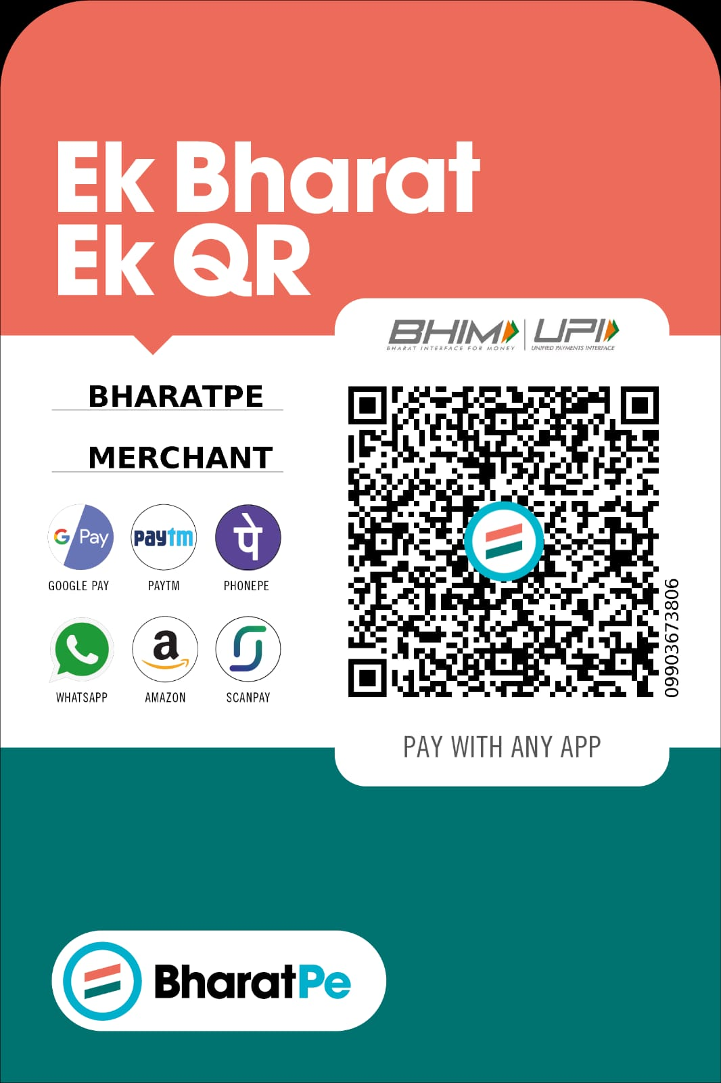
Quick calculation: Participation fees per candidate for each program

For 2 days - Rs. 3,800/- plus 18% GST
For International Participant $100

For 3 days - Rs. 5,700/- plus 18% GST
For International Participants $150

For details of discount check brochure.

Venue and Conducted by: Institute of Insurance and Risk Management (IIRM)
Financial District, Gachibowli,
Hyderabad, Telangana – 500 032 (India).
Tel: 040 2300 2041/42/43.
Website: www.theiirm.ac.in
Landmark: Opp to Q city, Beside IRDAI office

*******

